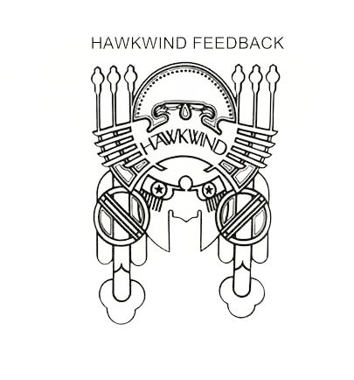
HAWKWIND FEEDBACK
Brian Tawn
27 Victory Road
Wisbech
Cambs
PE13 2PU

August 2016

Hello, Fellow Hawkwind Fans,

After a terrific Hawkeaster, Spring Tour and festivals (festivals which saw Tim Blake back with the band), we have exhausted the gigs so far booked for this year....but there is something to keep us going while we wait for more gigs to bridge the gap till more gigs are added for later this year....and don't forget, they play at HRH Prog V next year.

The good folk at The Gateway, Seaton (home of Hawkeaster) have achieved charity status for the venue (well done them!) and they have posted the following on Facebook.

“Sat 20th August will be a very special day at The Gateway. So from 1pm onwards we will be celebrating our Charity Status.....Patron Dave Brock and his band Hawkwind will be there. There will be fun, music and mayhem to mark the official renaming of the hall to 'Brock Hall'.....everyone welcome to just simply share in the fun and celebrations.....more news to follow asap.....oh and did I mention Captain will be 75 xxx.”

What a way to celebrate Dave Brock's 75th birthday! It won't be a full-on Hawkwind gig, but expect some acoustic stuff. It's a fun day. It's free entry and I think it will be an absolutely wonderful day. A gathering at The Gateway is always a joy and a morning stroll along the prom in the August sunshine sounds good to me too. Sadly, I can't go because I'm slowly recovering from a small operation and won't be fit to travel, so I'll be looking forward to what everyone else has to report on the event, along with photos, video clips etc. I hope to enjoy it second hand as it were.

In other news, I'm pleased to say that The Machine Stops album has been nominated for the best album in the 2016 Prog Awards.

The state of play with Hawkfan is that Hawkfan 45 is out, with my memories of Hawkeaster and the Spring Tour, along with a few photos. A few words about the St. Albans gig will be in Hawkfan 46, but more on that in a later letter.

Be of good cheer.

Brian.

